**Lesson 1**

**Flappy bird (beginner)**

**Bird**

1)Upload the flappy bird background. Then upload a flappy bird sprite.

2)Make it always spawn at **x:-120 and y:0**. If sprite has different costumes. **Add this**:

3)Make the bird move up and down by setting a velocity and changing it in a loop.

**Lesson 2**

**Pipes**

1)Find a pipe sprite or create one and call it pipe 1. Under the pipe costumes tab, duplicate 5 or more pipe costumes and make them different lengths.

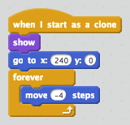2)Now it’s time to make them move. When the flag is clicked we want to **hide the first pipe** then **cone it ever 2 seconds.**

3)Let’s simply just make the pipes move across the screen. Set them **to x:240 & y:0**. And in a forever loop make it **move -4 steps**.

4)Now we must make the pipes disappear when they hit the end of the screen.

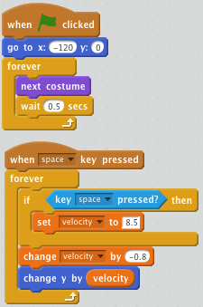

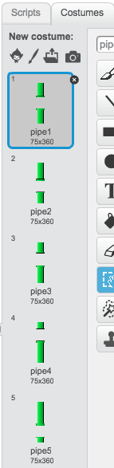

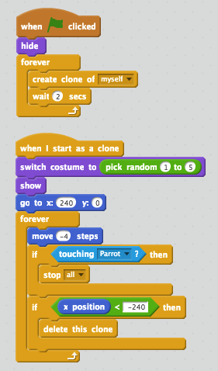

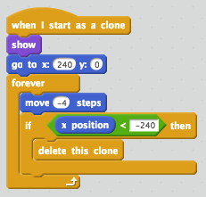

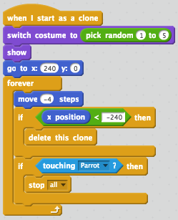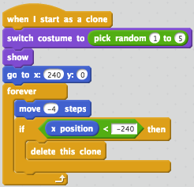5)Then to make the pipes switch to random positions, add **switch costume to (pick random number 1 to #OF COSTUMES)**.

7)Lastly, if the pipe touches the parrot, stop ALL.

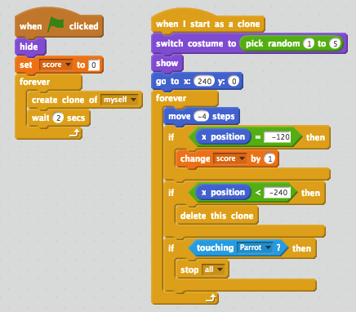**Lesson 3**

**Scoring & health**

1)Every time the bird passes a pipe the score should increase. **Create a variable**. Score = 0.

2) once it is passed the **x positions of the bird, it increases by 1**.

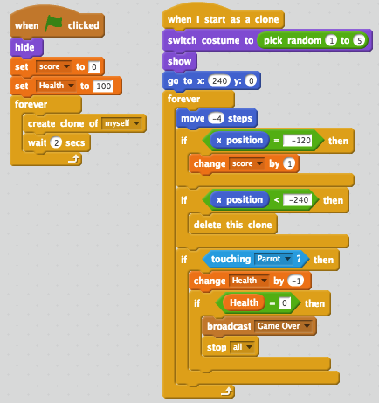3)Create a **health variable** and set it to **100**.

4)If it touches the parrot, change **health by -1. If it equals 0 then stop**.

5)If health = 0 then stop all.

**Game Over**

6)Create a game over sprite. Broadcast a game over message.

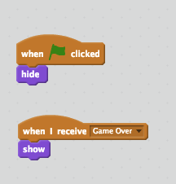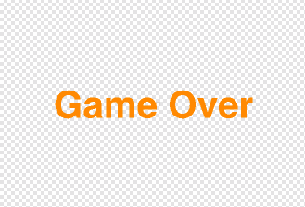7)The game over sprite should look like this:

Extra Challenges

1. Go to the bird sprite. If the bird hits the bottom of the screen, make the game end.